**User Manual for “URNeuroApp”**

Instructions for CSP analysis using URNeuroAPP:

1. In CSP analysis, raw EMG data is recorded using LabChart 8 software and saved in “.adicht” file format. The file name is generally given as “FDI_CSP_POST.adicht” or “FDI_CSP_PRE.adicht”. See the figure-1: a sample file name is marked by the red elliptical circle.   
     
   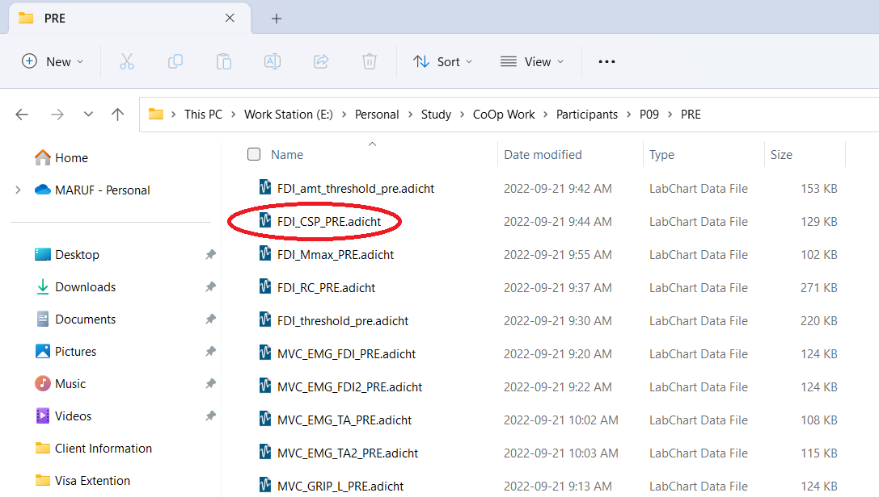  
    Figure 1: files for different studies.
2. This “.adicht” file needs to be converted into a “.txt” file for the CSP analysis using URNeuroApp software. To do this, the “FDI_CSP_***.adicht” needs to be opened by LabChat software, then go through File > Export > Save (FDI_CSP_***.txt) > OK, to save in text file format.  
     
   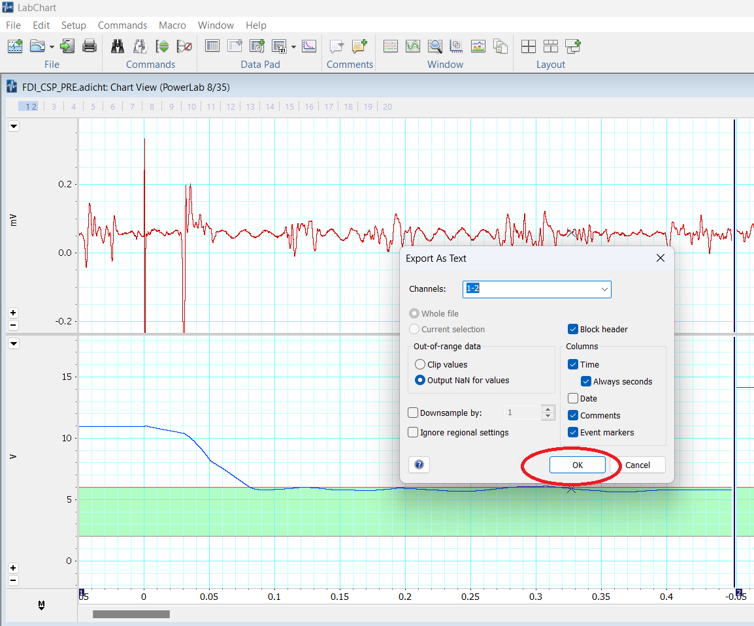
3. After Converting the .adicht to the .txt file, the “FDI_CSP_***.txt” file needs to be opened by URNeuroAPP.
   1. Run the URNeuroAPP.exe file   
      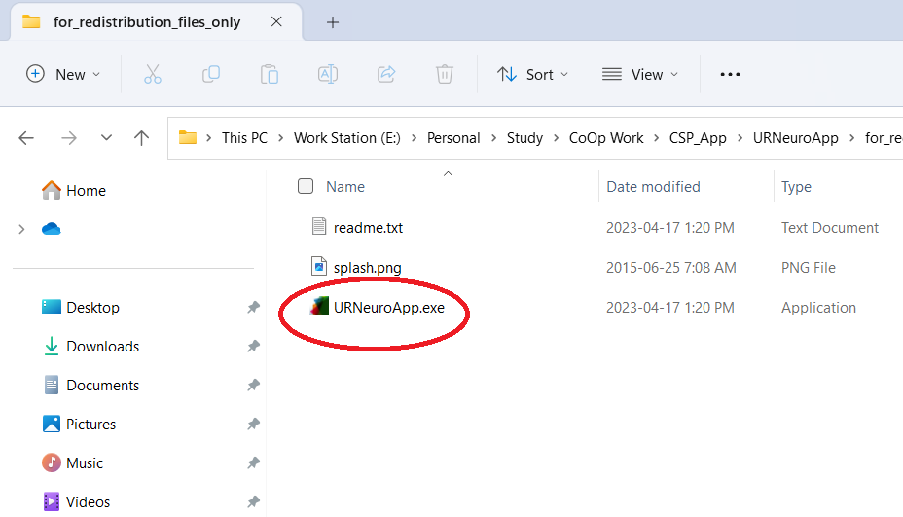
   2. After opening the URNeuroApp, make sure that the CSP tab is selected, then go through File>Open> Choose a file (make sure the file type is .txt and in correct format) > Open and Choose the file.

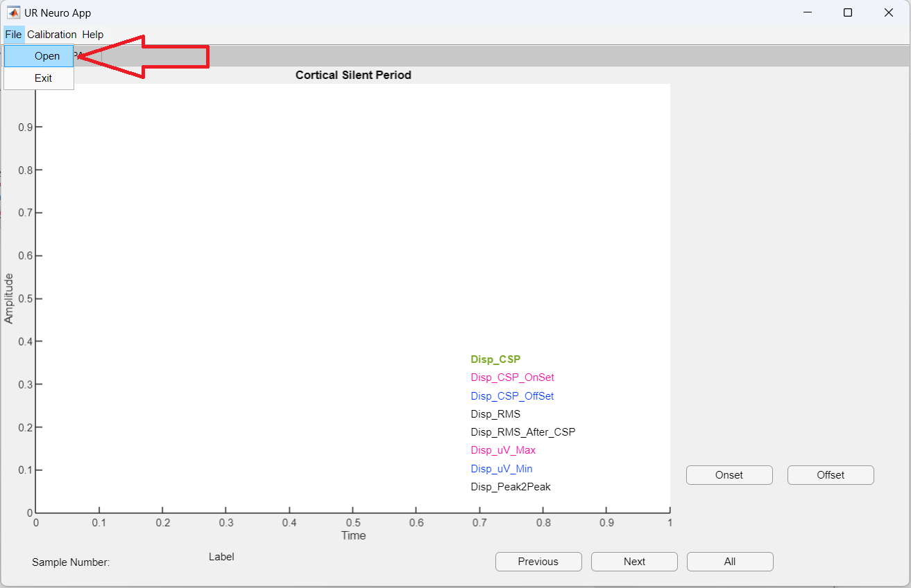  
  
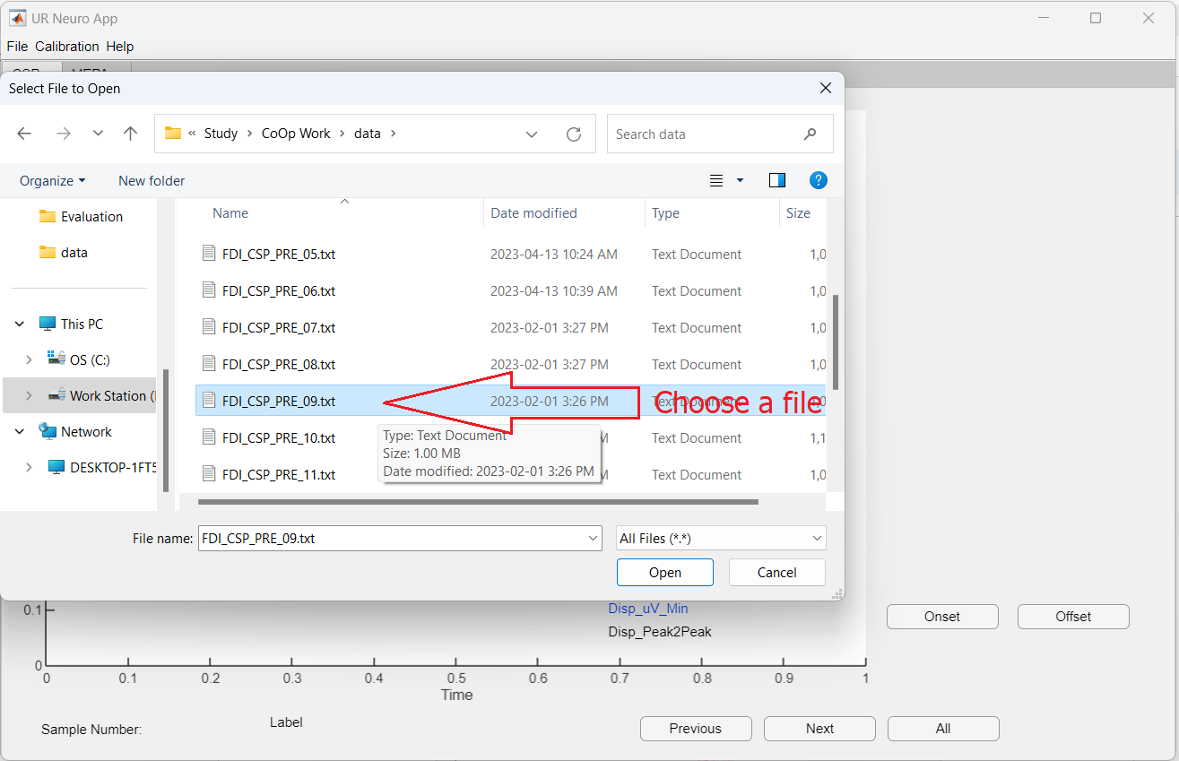

* 1. A few seconds later, the URNeuroApp will show the graph of the EMG signal with relevant analytical information.  
       
     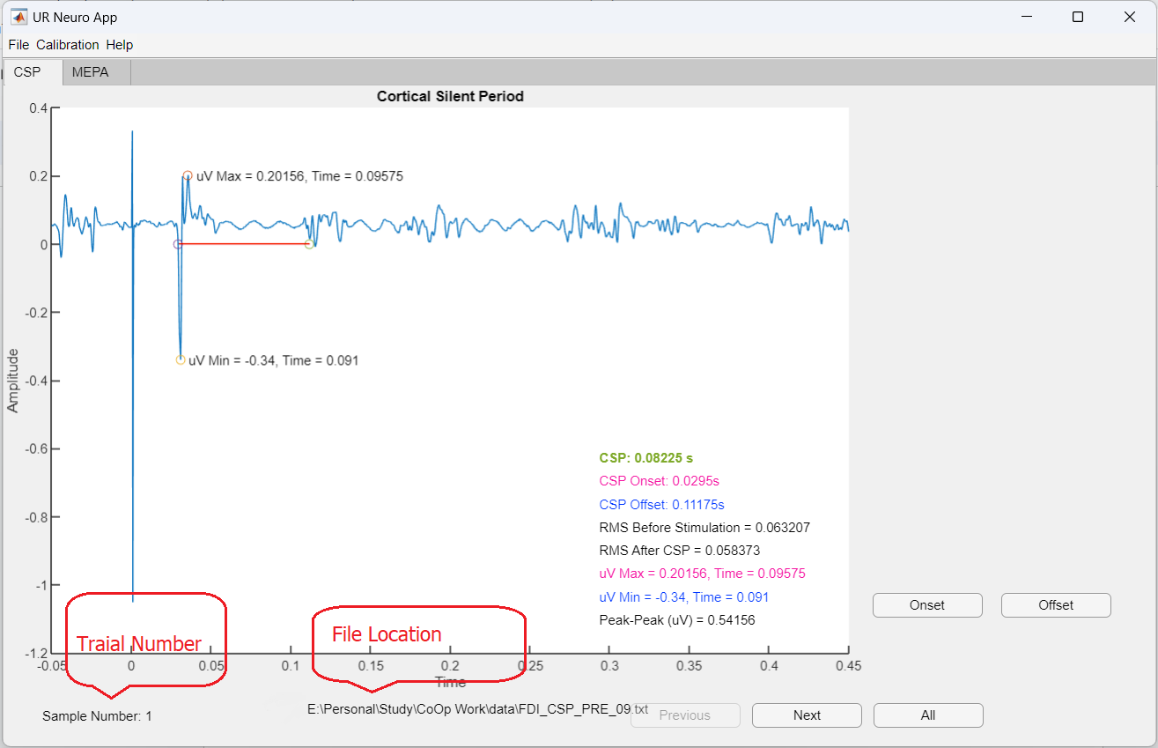

1. By clicking the “Next” and “Previous” buttons, we can view and go through a different trial in ascending order or descending order.   
   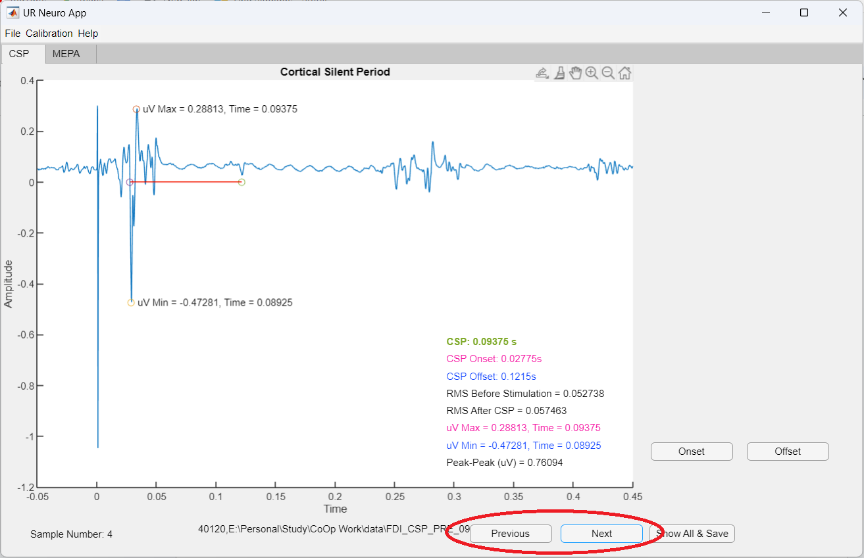
2. If you click on the “Show All & Save” button, this will analyze all the trials at a time, show the CSP duration of all trials at the right sidebar, and save the analyzed data in the “SavedResult.txt” file [You can select the directory of where you want the file to save]

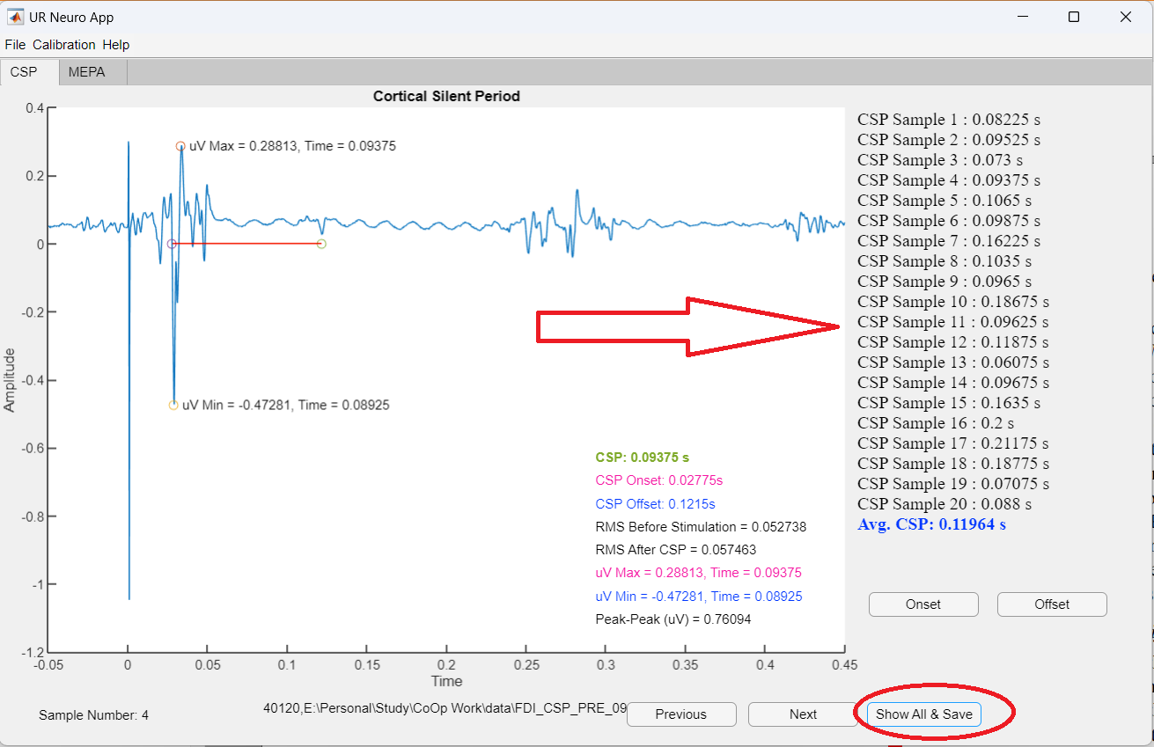  
  
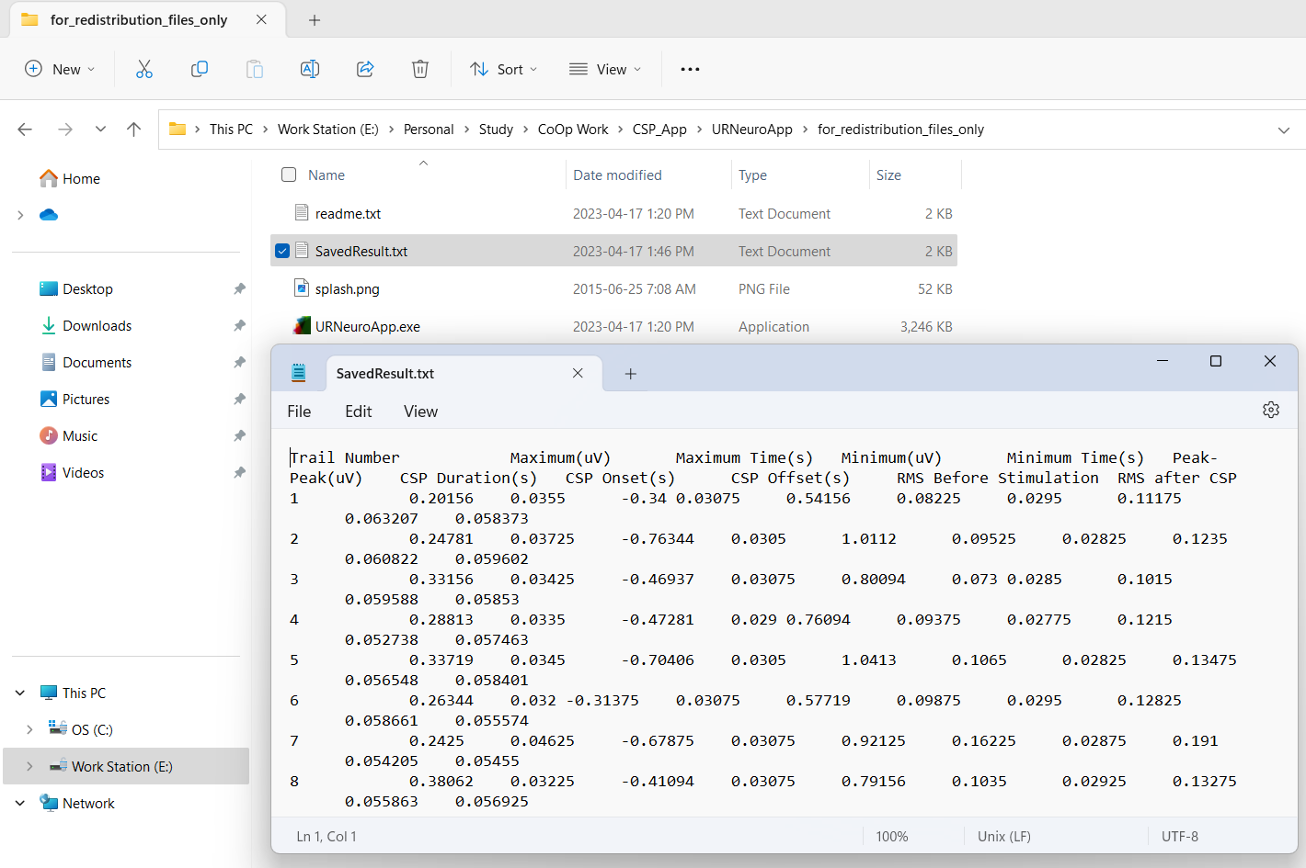  
The “SavedResult.txt” file contains all the analyzed data of CSP. The data can be copied and past to the MS Excel/Google-sheet application.   
  
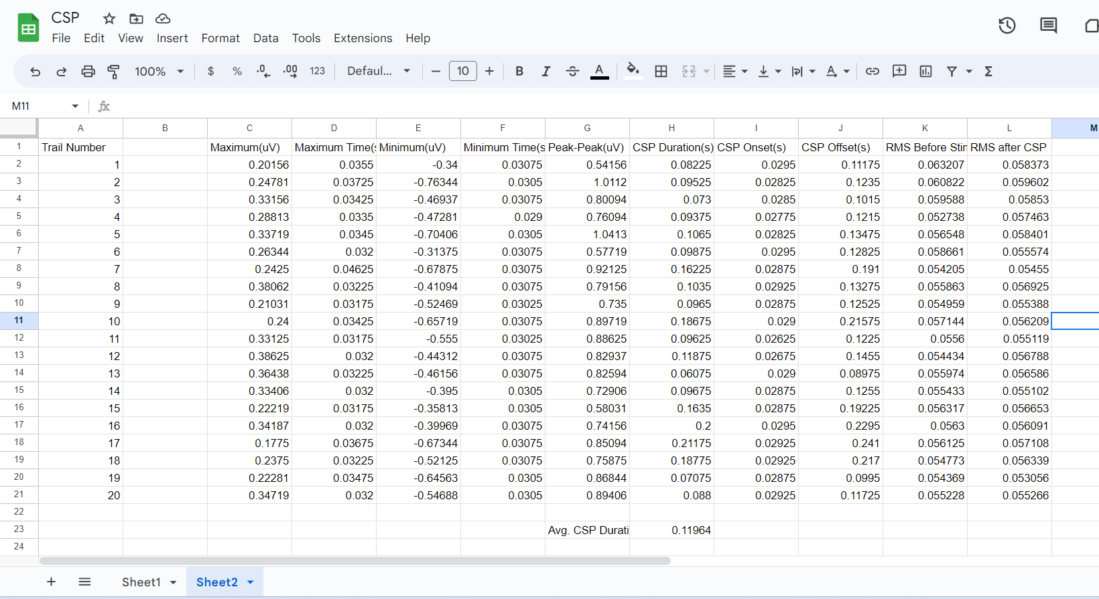

1. If any NeuroApp made any mistake in the automatic detection of CSP, a user can correct the error by manually selecting the onset and offset of the CSP duration using the “Onset” and “Offset” buttons.   
   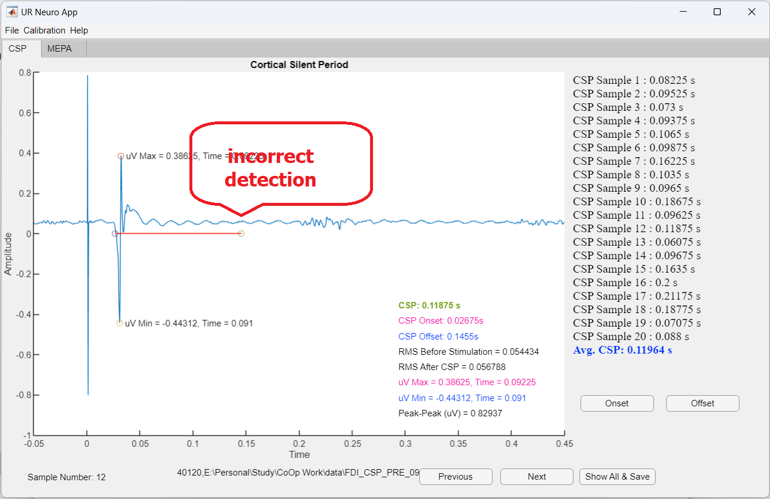  
     
   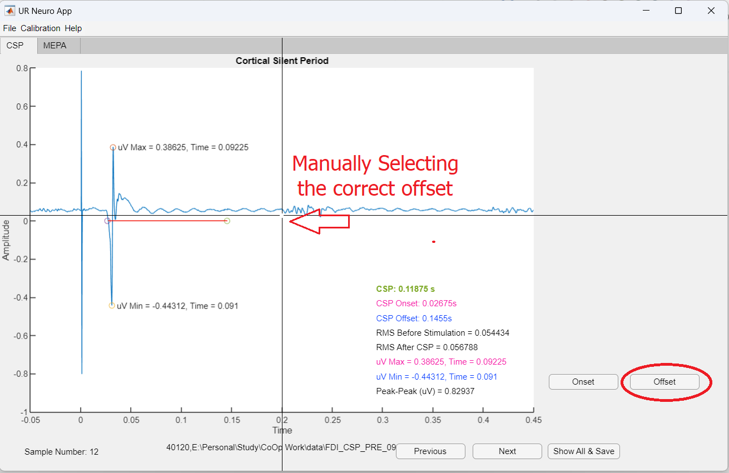  
     
   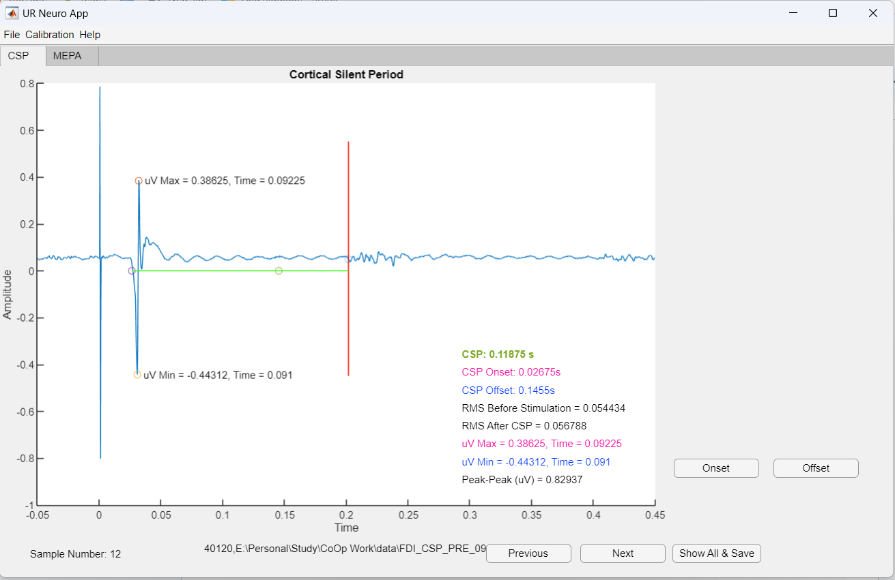
2. After manual correction, please click on “Show All & Save” to save the correct result in the “savedResult.txt” file.

**Instructions for MEPA analysis using URNeuroAPP:**

1. For MEPA analysis on URNeuroApp, typically file name such as FDI_RC_***.txt or FDI_threshold_***.txt is opened on the application. There are some other typical files for MEPA analysis are listed below:

FDI_threshold_***.txt

FDI_RC_***.txt

TA_CSP_***.txt

TA_threshold_***.txt  
  
See the figure below:  
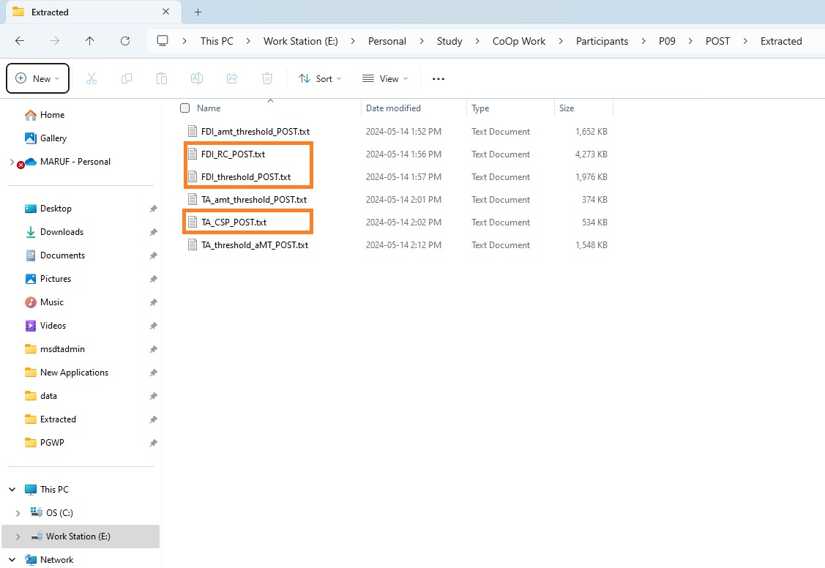

1. Open the **URNeuronApp**, Select **MEPA** from the tab on top. Go to File>Open>Choose file.   
     
   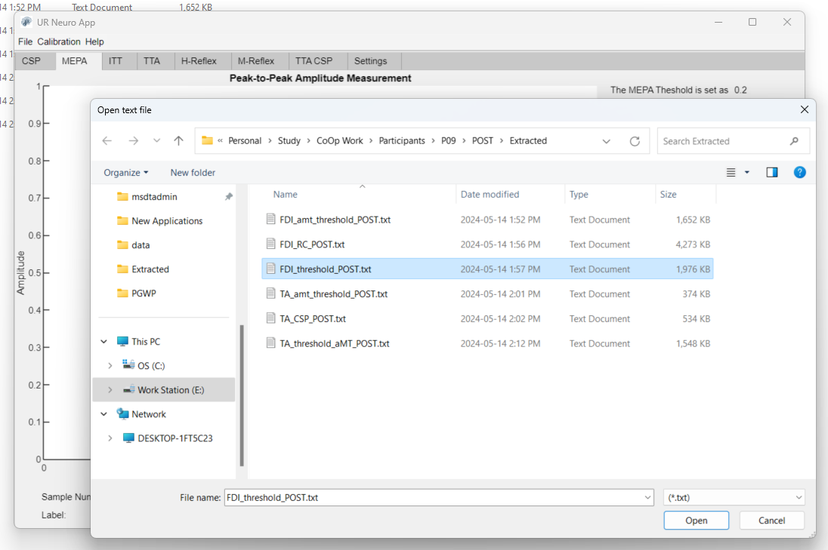
2. A few seconds later, the URNeuroApp will show the graph of the EMG signal with relevant analytical information on the MEPA tab window.  
   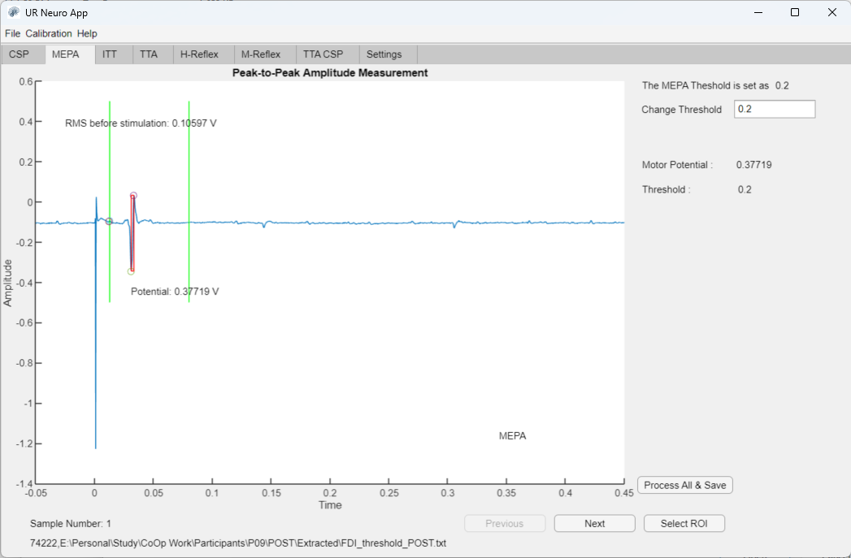
3. 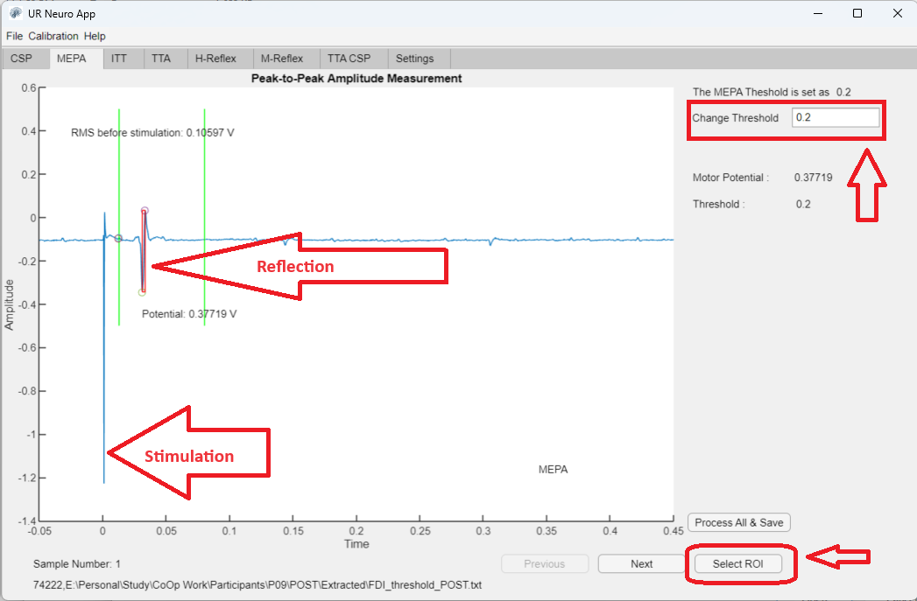
4. 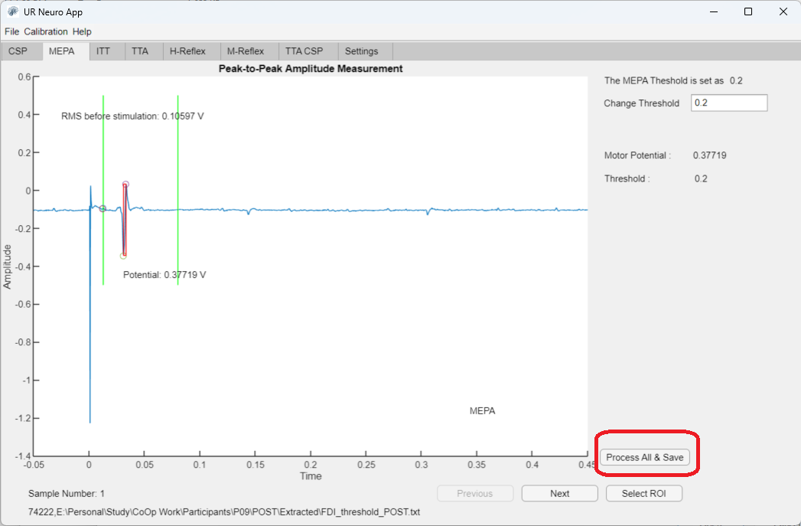
5. 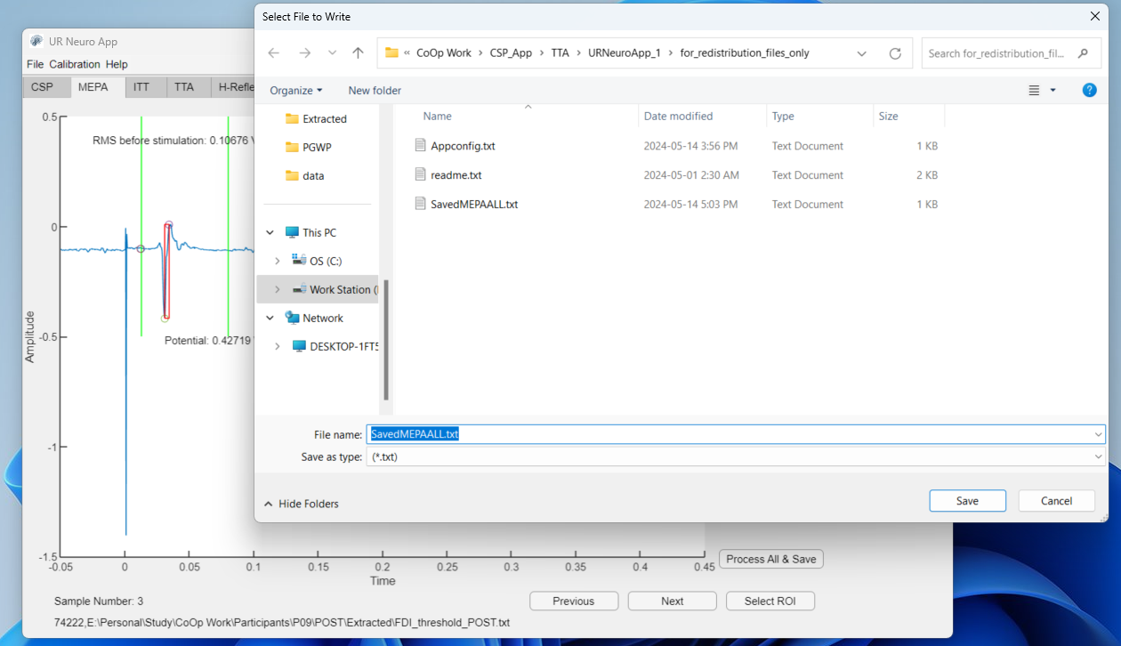
6. 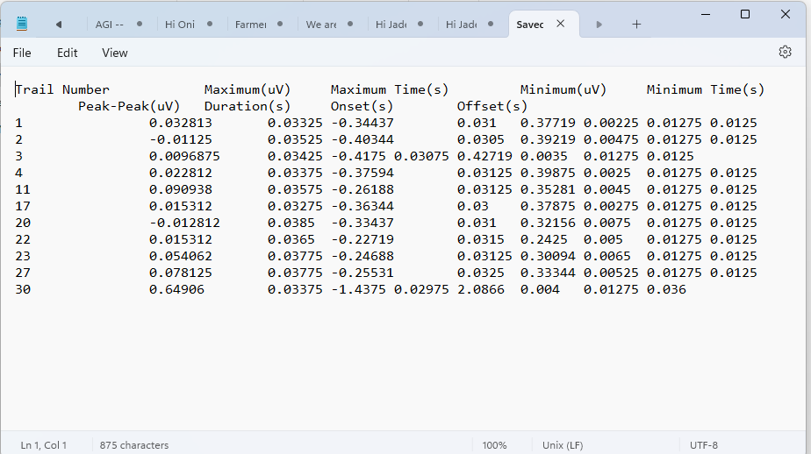

**Interpolated Twitch (ITT) Analysis:**

This section provides instructions for performing ITT analysis using the UR Neuro App.

1. **Loading ITT Files**  
   To begin ITT analysis, ensure your files are named with a suffix "_ITT". Follow these steps to load a file:  
   1. Open the UR Neuro App.
   2. Navigate to the ITT tab.
   3. Click File > Open.
   4. Choose the desired ITT file from your directory.
   5. Click OK.

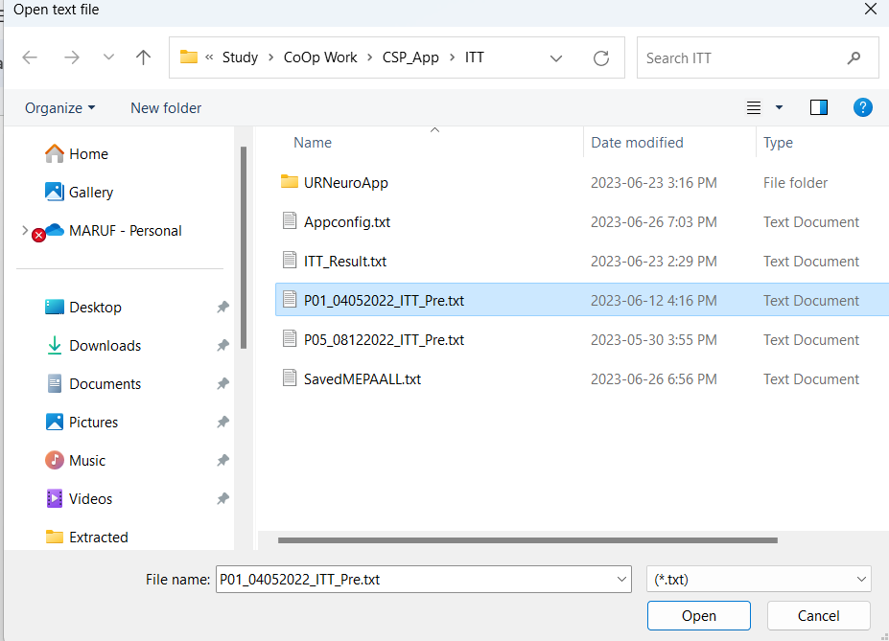

1. Analyzing the Graph Plot

After loading the ITT file, the app will display a graph plot. Here are the key components:

* 1. Blue Signal: Represents the EMG signal. Vertical large blue signals indicate stimulation.
  2. Orange Signal: Represents force current (measured in volts). The graph shows three stages of stimulation, where the force current increases and then drops.
  3. Baseline Level (0): The base level before stimulation.
  4. Peak Levels (A, B, C):
     1. A (First Peak): How high the force current level goes before it goes down again after the first stimulation.
     2. B (Second Peak): How high the force current level goes before it goes down again after the second stimulation.
     3. C (Control Peak): How high the force current level goes before it goes down again at control stimulation.

The app calculates the values of ITT as follows:

* 1. iTT_a (A - Max)
  2. iTT_b (B - Max)
  3. iTT_c

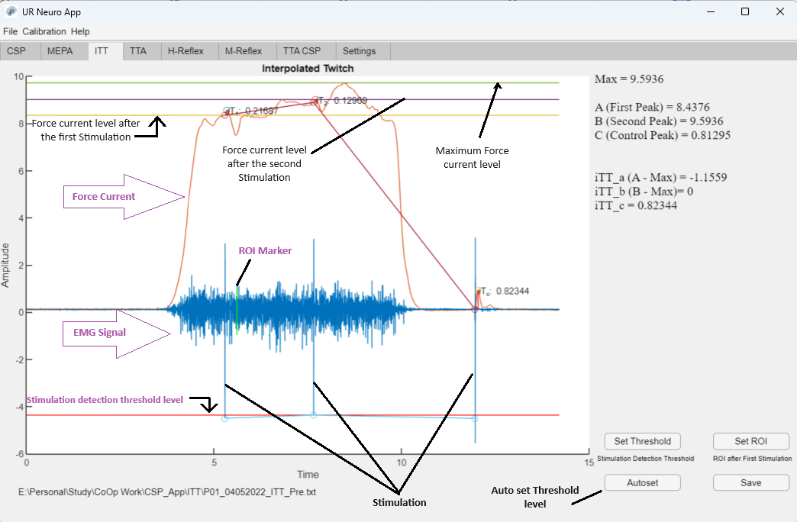

1. **Adjusting Analysis Parameters:**  
     
   In the bottom right corner, you can adjust the analysis parameters:
   1. **Threshold Setting:** The app automatically detects simulation, so manual threshold setting is not usually required. If necessary, click Set Threshold to adjust.
   2. **ROI Selection:** Region of Interest (ROI) selection is manual. To set the ROI, click Set ROI, then click on the desired location in the graph. A green ROI marker will appear, and the ITT analysis will update accordingly.
   3. **Save Data:** Click Save to store the analysis results.
2. Saving and Viewing ITT Analysis Reports  
     
   After the analysis, you can save the results. The saved report includes key metrics such as Max, First Peak, Second Peak, Control Peak, and calculated ITT values.

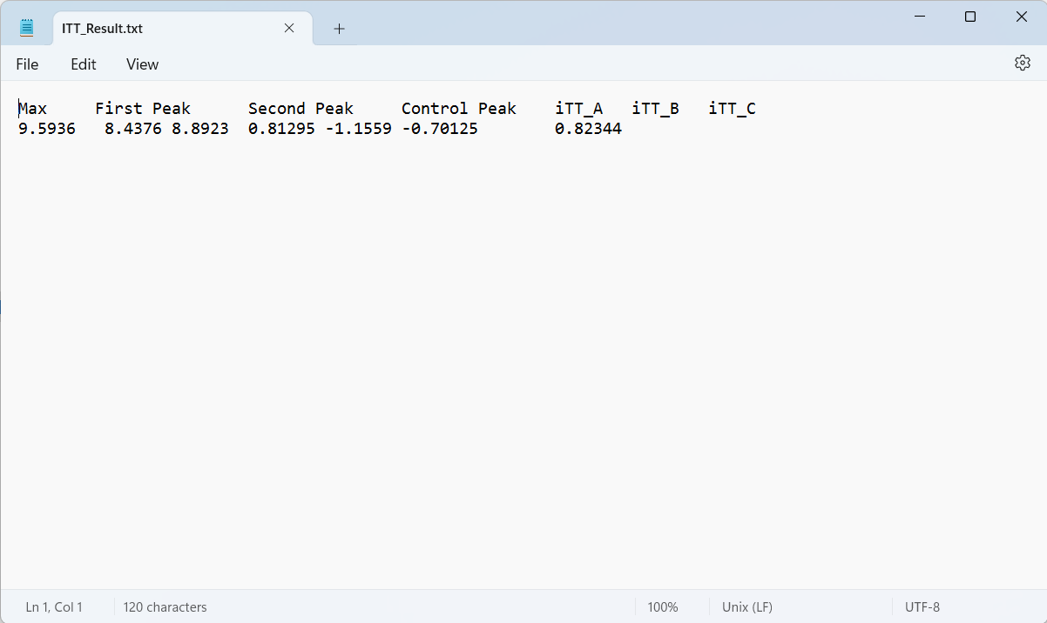

**Toe Tapping Accuracy (TTA) :**

This guide will help you understand and use the app to analyze Toe Tapping Accuracy (TTA) in participants. The app is designed to handle and analyze data from dual-task paradigms in people with Multiple Sclerosis (PwMS).

#### **Terminology**

1. **Dual Task in PwMS:**
   * **DDM (Dual Motor - Motor):** Tasks involving simultaneous motor activities.
   * **LNLC (Low Novelty / Low Complexity):** No external beat, tap at a steady self-selected beat.
   * **LNHC (Low Novelty / High Complexity):** No external beat, tap as quickly as possible.
   * **HNLC (High Novelty / Low Complexity):** External steady beat, measure how far the toe tap is from the external beat.
   * **HNHC (High Novelty / High Complexity):** External varying beat, measure error.

**Study Procedure**

Participants press a pedal when they hear a beep sound. The latency of their response (time taken to press the pedal after hearing the beep) is recorded using electronic devices and LabChart software. These recordings are converted to text files for analysis using URNeuroApp.

### **How to Use URNeuroApp**

#### **Loading TTA Files**

1. **Open the URNeuroApp:**
   * Ensure you have the correct file (e.g., “DMM_HNHC_P06”, “DMM_HNLC_P06”).
2. **Navigate to the TTA tab:**
   * Click **File** > **Open**.
   * Select the desired TTA file from your directory.
   * Click **OK**.

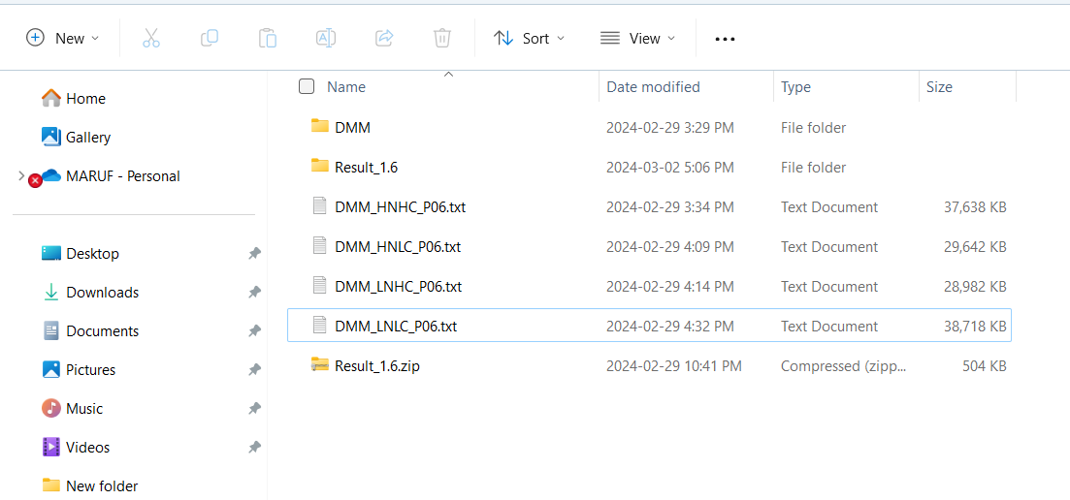

After loading the file, the following graphs will be displayed on the app’s screen:

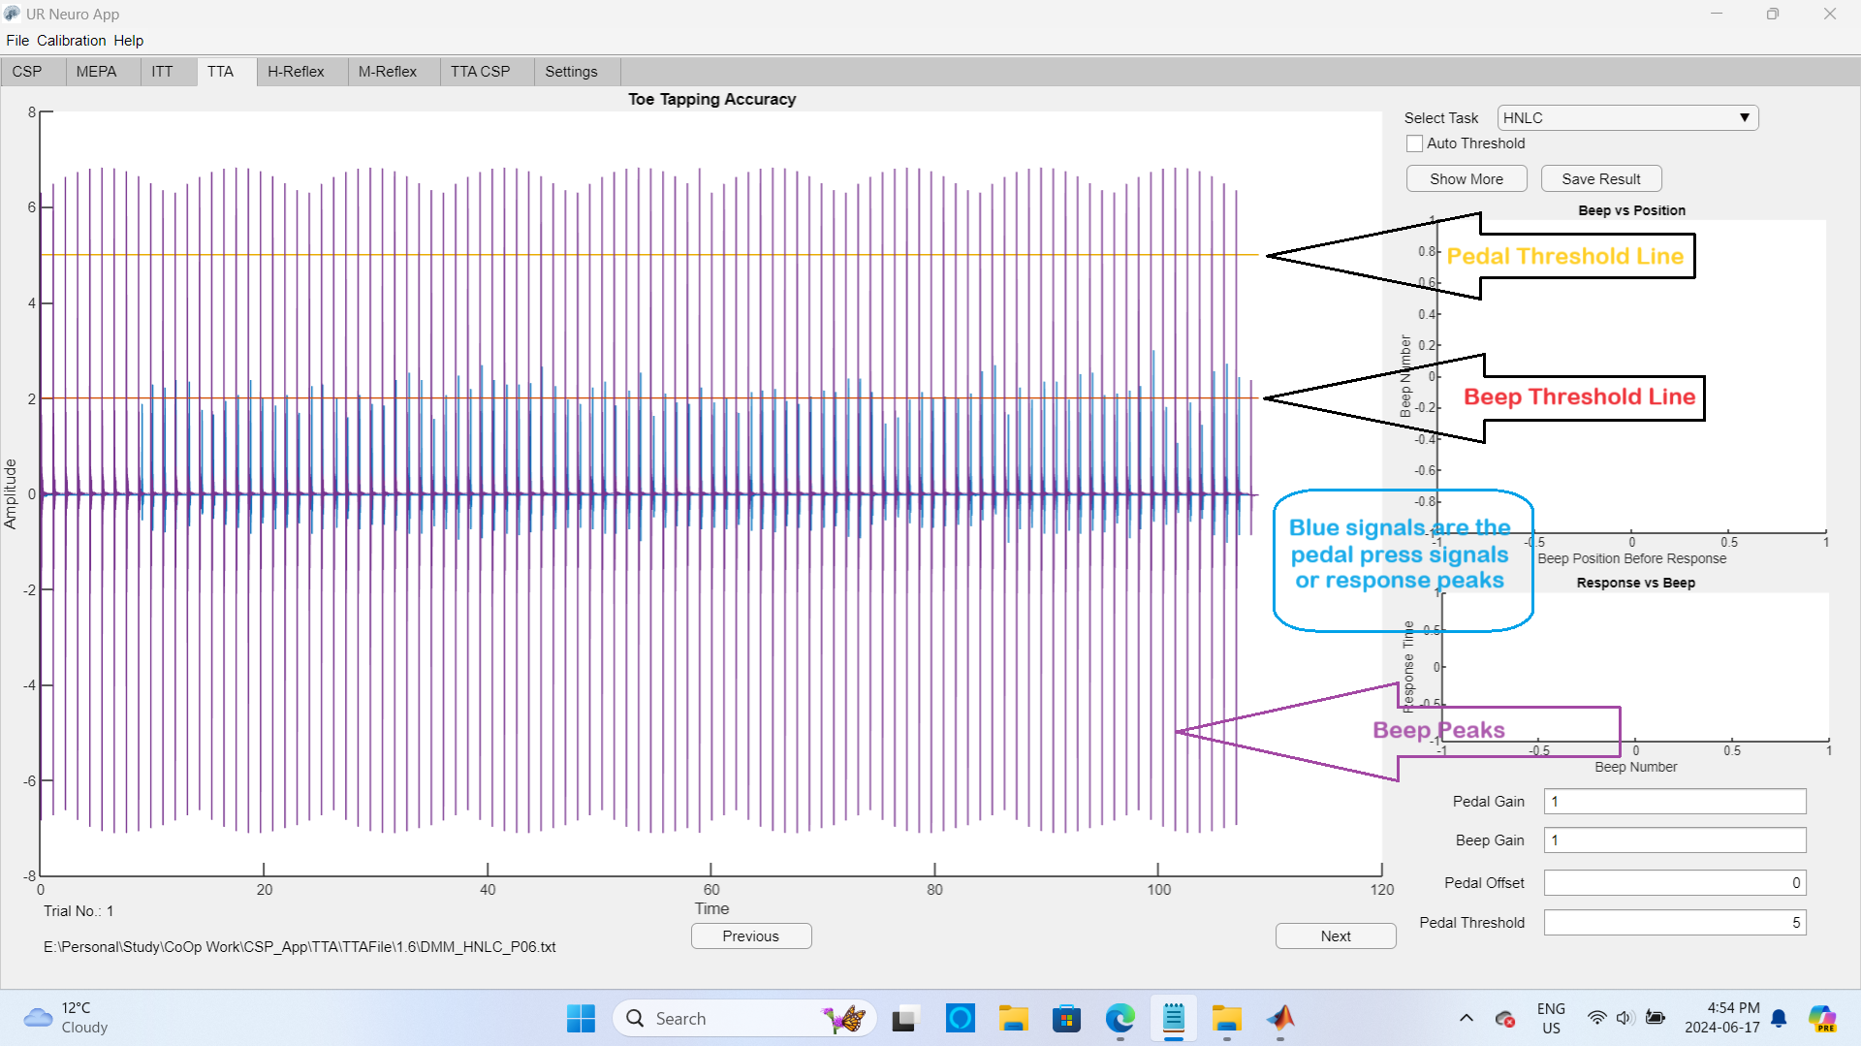

**Vanilla signals:** Beep sound.

**Blue signals:** Participant’s pedal press responses.

**Yellow line:** Threshold line for response signal detection.

**Red line:** Threshold line for beep signal detection.

After clicking the auto threshold:

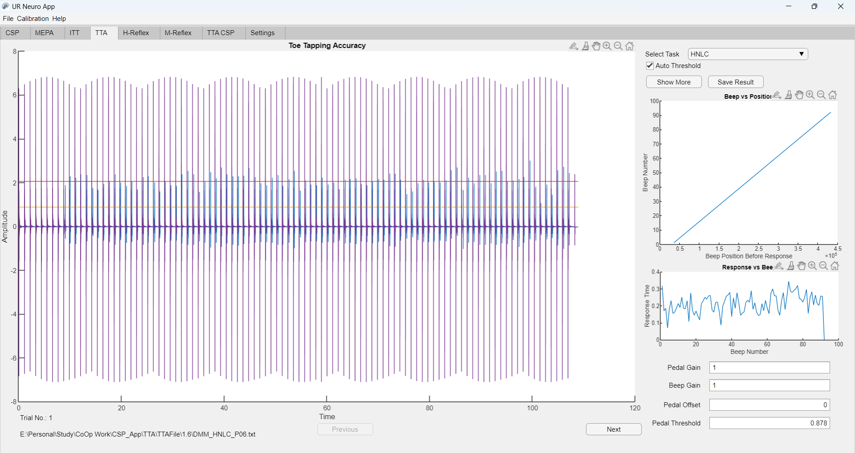

#### **Auto Threshold**

1. **Automatic Detection:**
   * Click the **Auto Threshold** button to automatically set the pedal and beep thresholds. This will measure the required analysis. If the automatic system cannot analyze the signals, you may need to manually set the threshold level, gain, and offset.
2. **Manual Adjustment:**
   * **Pedal Threshold Level:** Set at a level where it touches or crosses all pedal peaks, depending on the signal's amplitude.
   * **Pedal Gain and Offset:** Adjust the pedal signals' gain and offset using the options at the bottom right corner of the app.
   * **Beep Gain:** Adjust the beep gain so that all peaks cross the beep threshold line (red line).

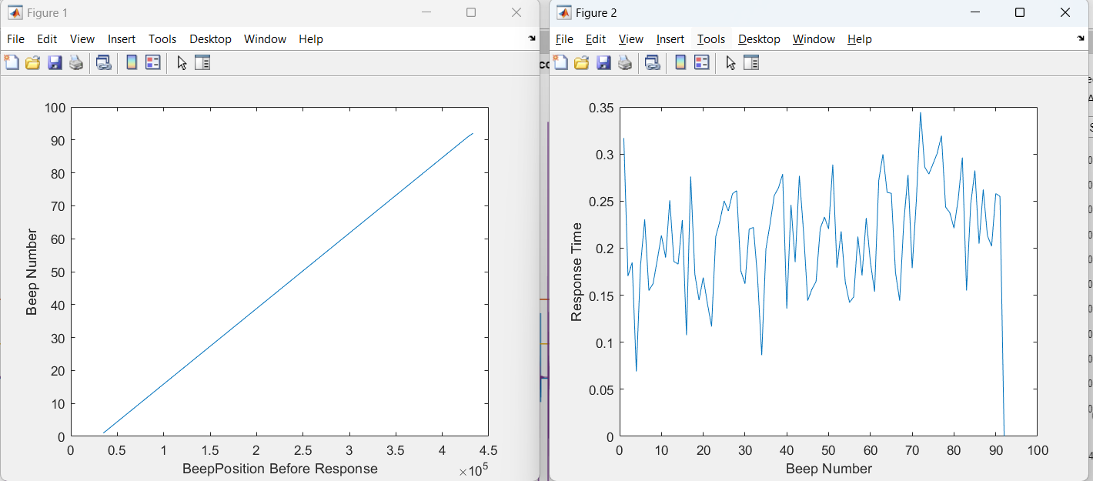

#### **Analyzing the Graphs**

1. **Graph Interpretation:**
   * **Beep vs. Position Graph:** Understand whether the beeps are in a consistent or varying rhythm.
   * **Response Time vs. Beep Number Graph:** Analyze the time taken by participants to respond to each beep.

#### **Additional Features**

1. **Show More:**
   * Click the **Show More** button to view larger graphs.
2. **Save Results:**
   * Click the **Save Result** button to save the analyzed results.

### **H-Reflex Analysis**

#### **Introduction**

This section will guide you through the process of analyzing H-Reflex data using URNeuroApp. Ensure your files are named with a suffix "H-reflex_**" before beginning the analysis.

#### **Loading H-Reflex Files**

1. **Open the URNeuroApp:**
   * Navigate to the H-Reflex tab.
   * Click **File** > **Open**.
   * Choose the desired H-Reflex file from your directory.
   * Click **OK**.

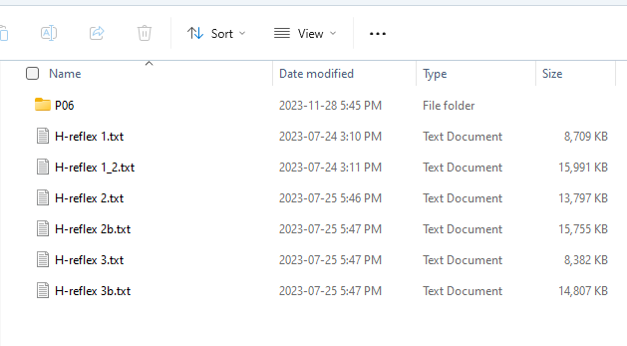

#### **Interpreting the Graphs**

After loading the H-Reflex file, the app will display a graph plot as shown below.

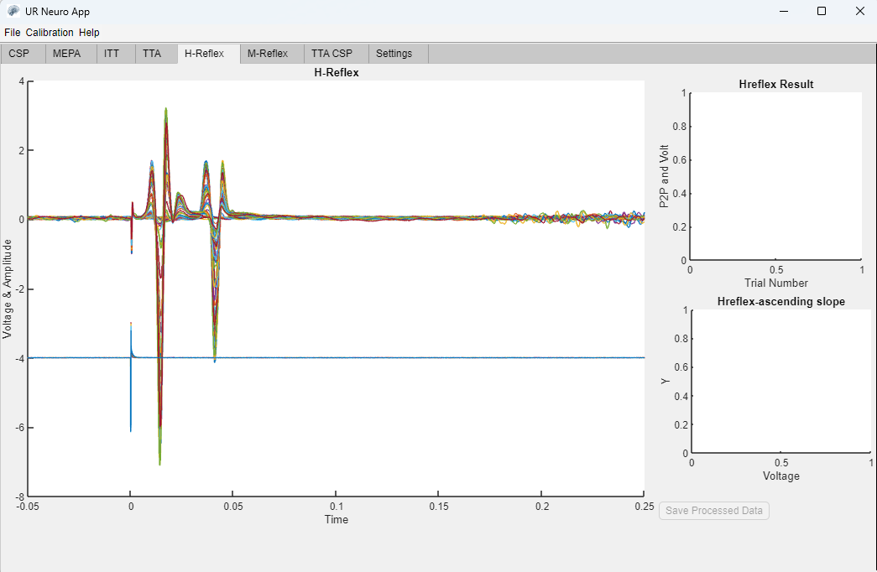

* **Single Blue Signal:** Represents the voltage/current level. The base of the blue signal is 0-level, but a negative offset of -4 is added to make it visible in the plot.
* **Multi-Colored Signals:** Represent the EMG amplitudes. Signals from each trial overlap each other.

#### **Selecting the Region of Interest (ROI)**

1. Select the region of interest (ROI) from the multi-colored signals where two significant peaks are visible.
2. Hover the mouse pointer over the signals and mark the interested positions as shown in the picture below.

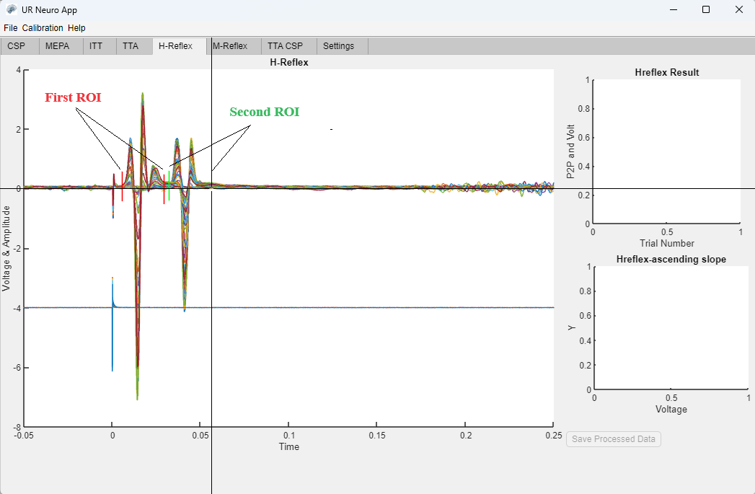

#### **Analyzing the H-Reflex Data**

After selecting two ROIs, the H-reflex analysis will be shown in the right-side graphs as illustrated below.

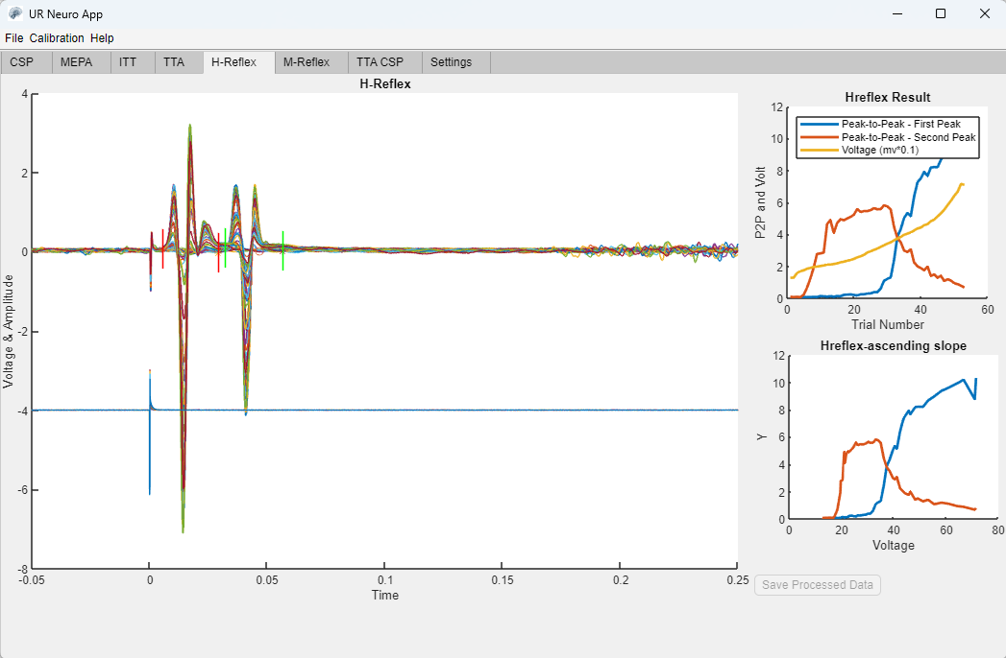

* **Further Analysis:** To see more detailed graphs, click on the H-reflex Result graph and H-reflex-ascending slope graph from the app window. This will enlarge the graphs and further process data like slope calculation, H-max, M-max, 5-percent, and 50-percent H-max.

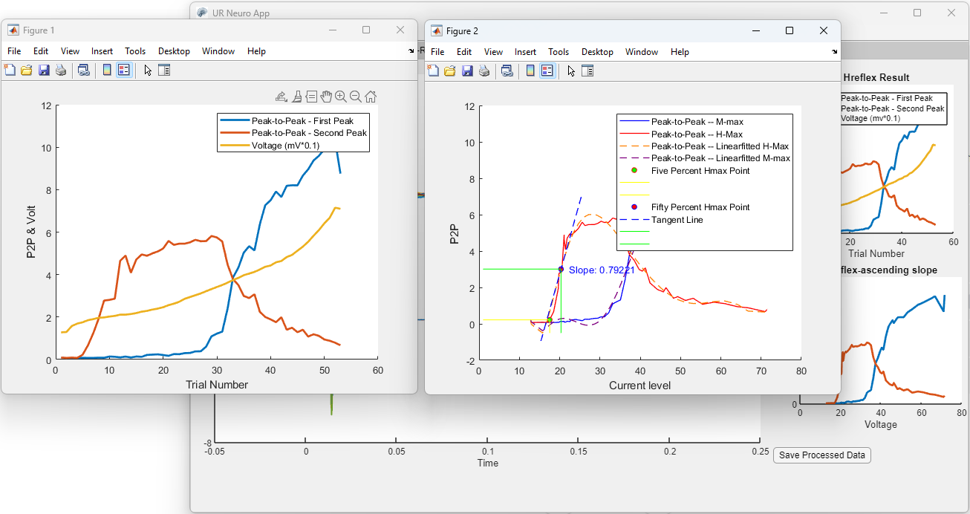

#### **Understanding the Results**

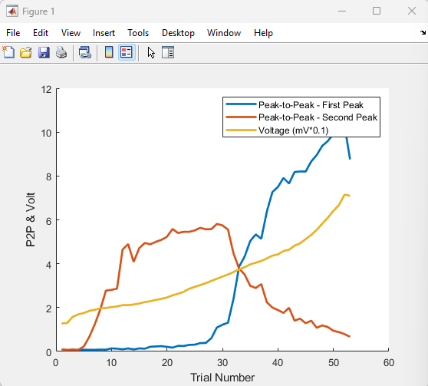

* **Peak-to-Peak Amplitude:** Displays the peak-to-peak amplitude of both peaks of the multi-colored signals (where each color represents each trial), represented by blue and red signal lines. Yellow signal lines represent the peak voltage/current level at each trial.

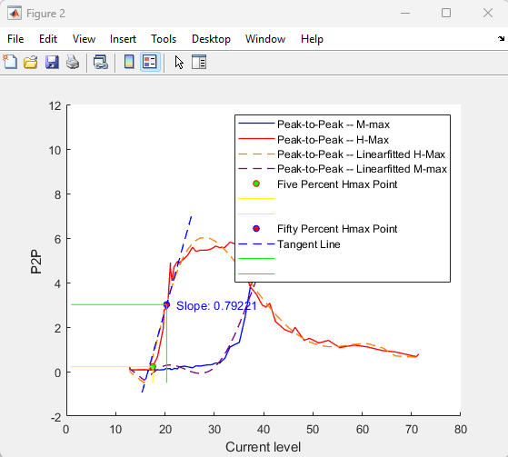

* **Current Level Representation:** Peak-to-peak M-max and H-max are represented with respect to Current Level. The orange and vanilla dashed lines represent the linearly fitted H-max and M-max, respectively. The blue dashed line represents the tangent line of the H-max.

#### **Saving the Results**

You can save the results by clicking on the **Save Processed Data** button.

**M-Reflex:**

Same as H-Reflex.

**TTA CSP:**

TTA-CSP is the Cortical Silent Period analysis in the Toe-Tapping Accuracy study.

This section will guide you through the process of analyzing TTA CSP data using URNeuroApp.

#### **Loading TTA Files**

1. **Open the URNeuroApp:**
   * Ensure you have the correct file (e.g., “DMM_HNHC_P06”, “DMM_HNLC_P06”).
2. **Navigate to the TTA CSP tab:**
   * Click **File** > **Open**.
   * Select the desired TTA file from your directory.
   * Click **OK**.

After loading the file, the app will display the EMG signals with several stimulations.

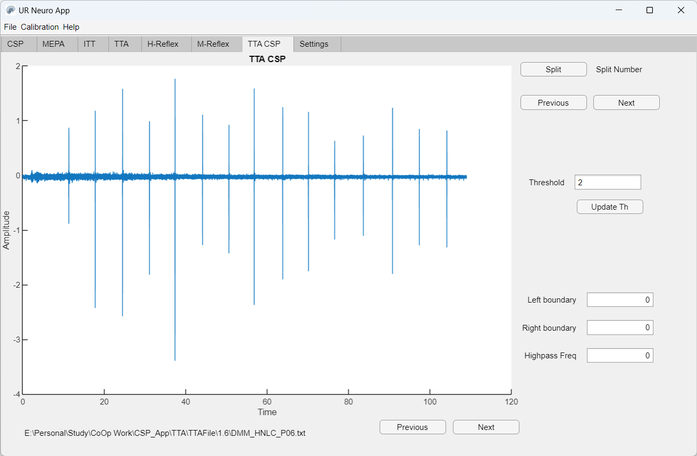

In the graph above, the EMG signals are displayed with several stimulations.

#### **Interpreting the Graphs**

* **Threshold Value Adjustment:** Update the threshold value so that it crosses every stimulation. The app automatically detects each stimulation by marking red circles and lines on each stimulation peak, as shown in the image below.

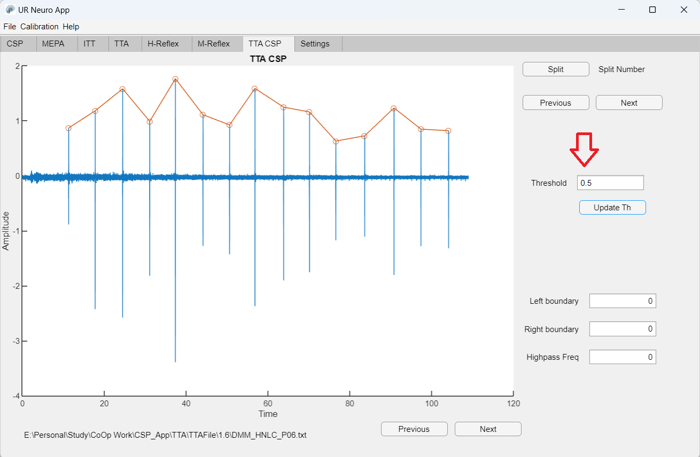

#### **Splitting the Signal Window**

1. **Split the Signal Window:**
   * Click the **Split** button at the top right corner. This will split the signal window for each stimulation and start displaying CSP analysis of the first stimulation.
2. **Navigating through Stimulations:**
   * Use the **Next** and **Previous** buttons to see other stimulations’ CSP analysis. See the picture below.

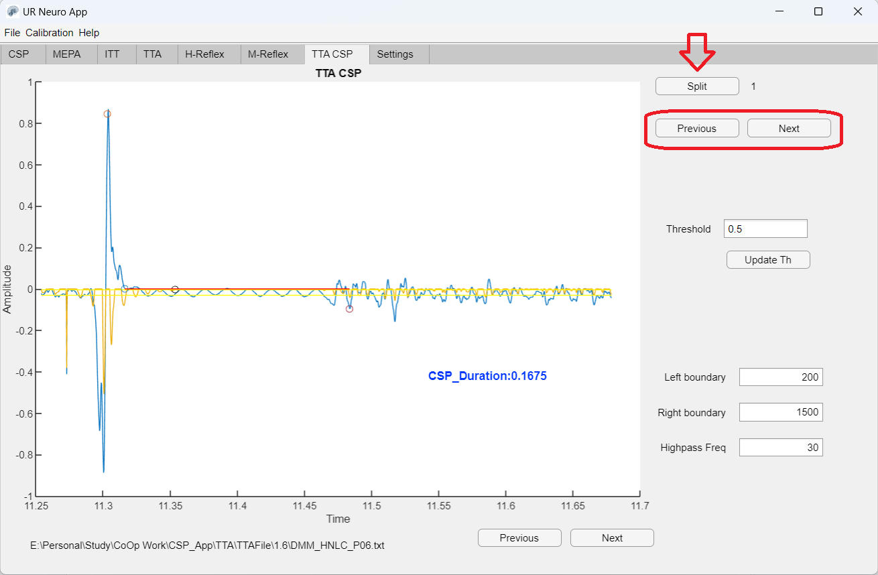

In the picture above, the CSP duration is displayed on the graph window.

**Configuration Options:** Located at the bottom right of the app window, these options allow you to select the size of each stimulation window.

* **Left Boundary:** Number of data points shown before the stimulation.
* **Right Boundary:** Number of data points shown after the stimulation.
* **Highpass Frequency:** Option for filtering the signal for better automatic detection of the CSP duration. The default value is 30, which is generally suitable for most processing needs.

Thanks.